MARU
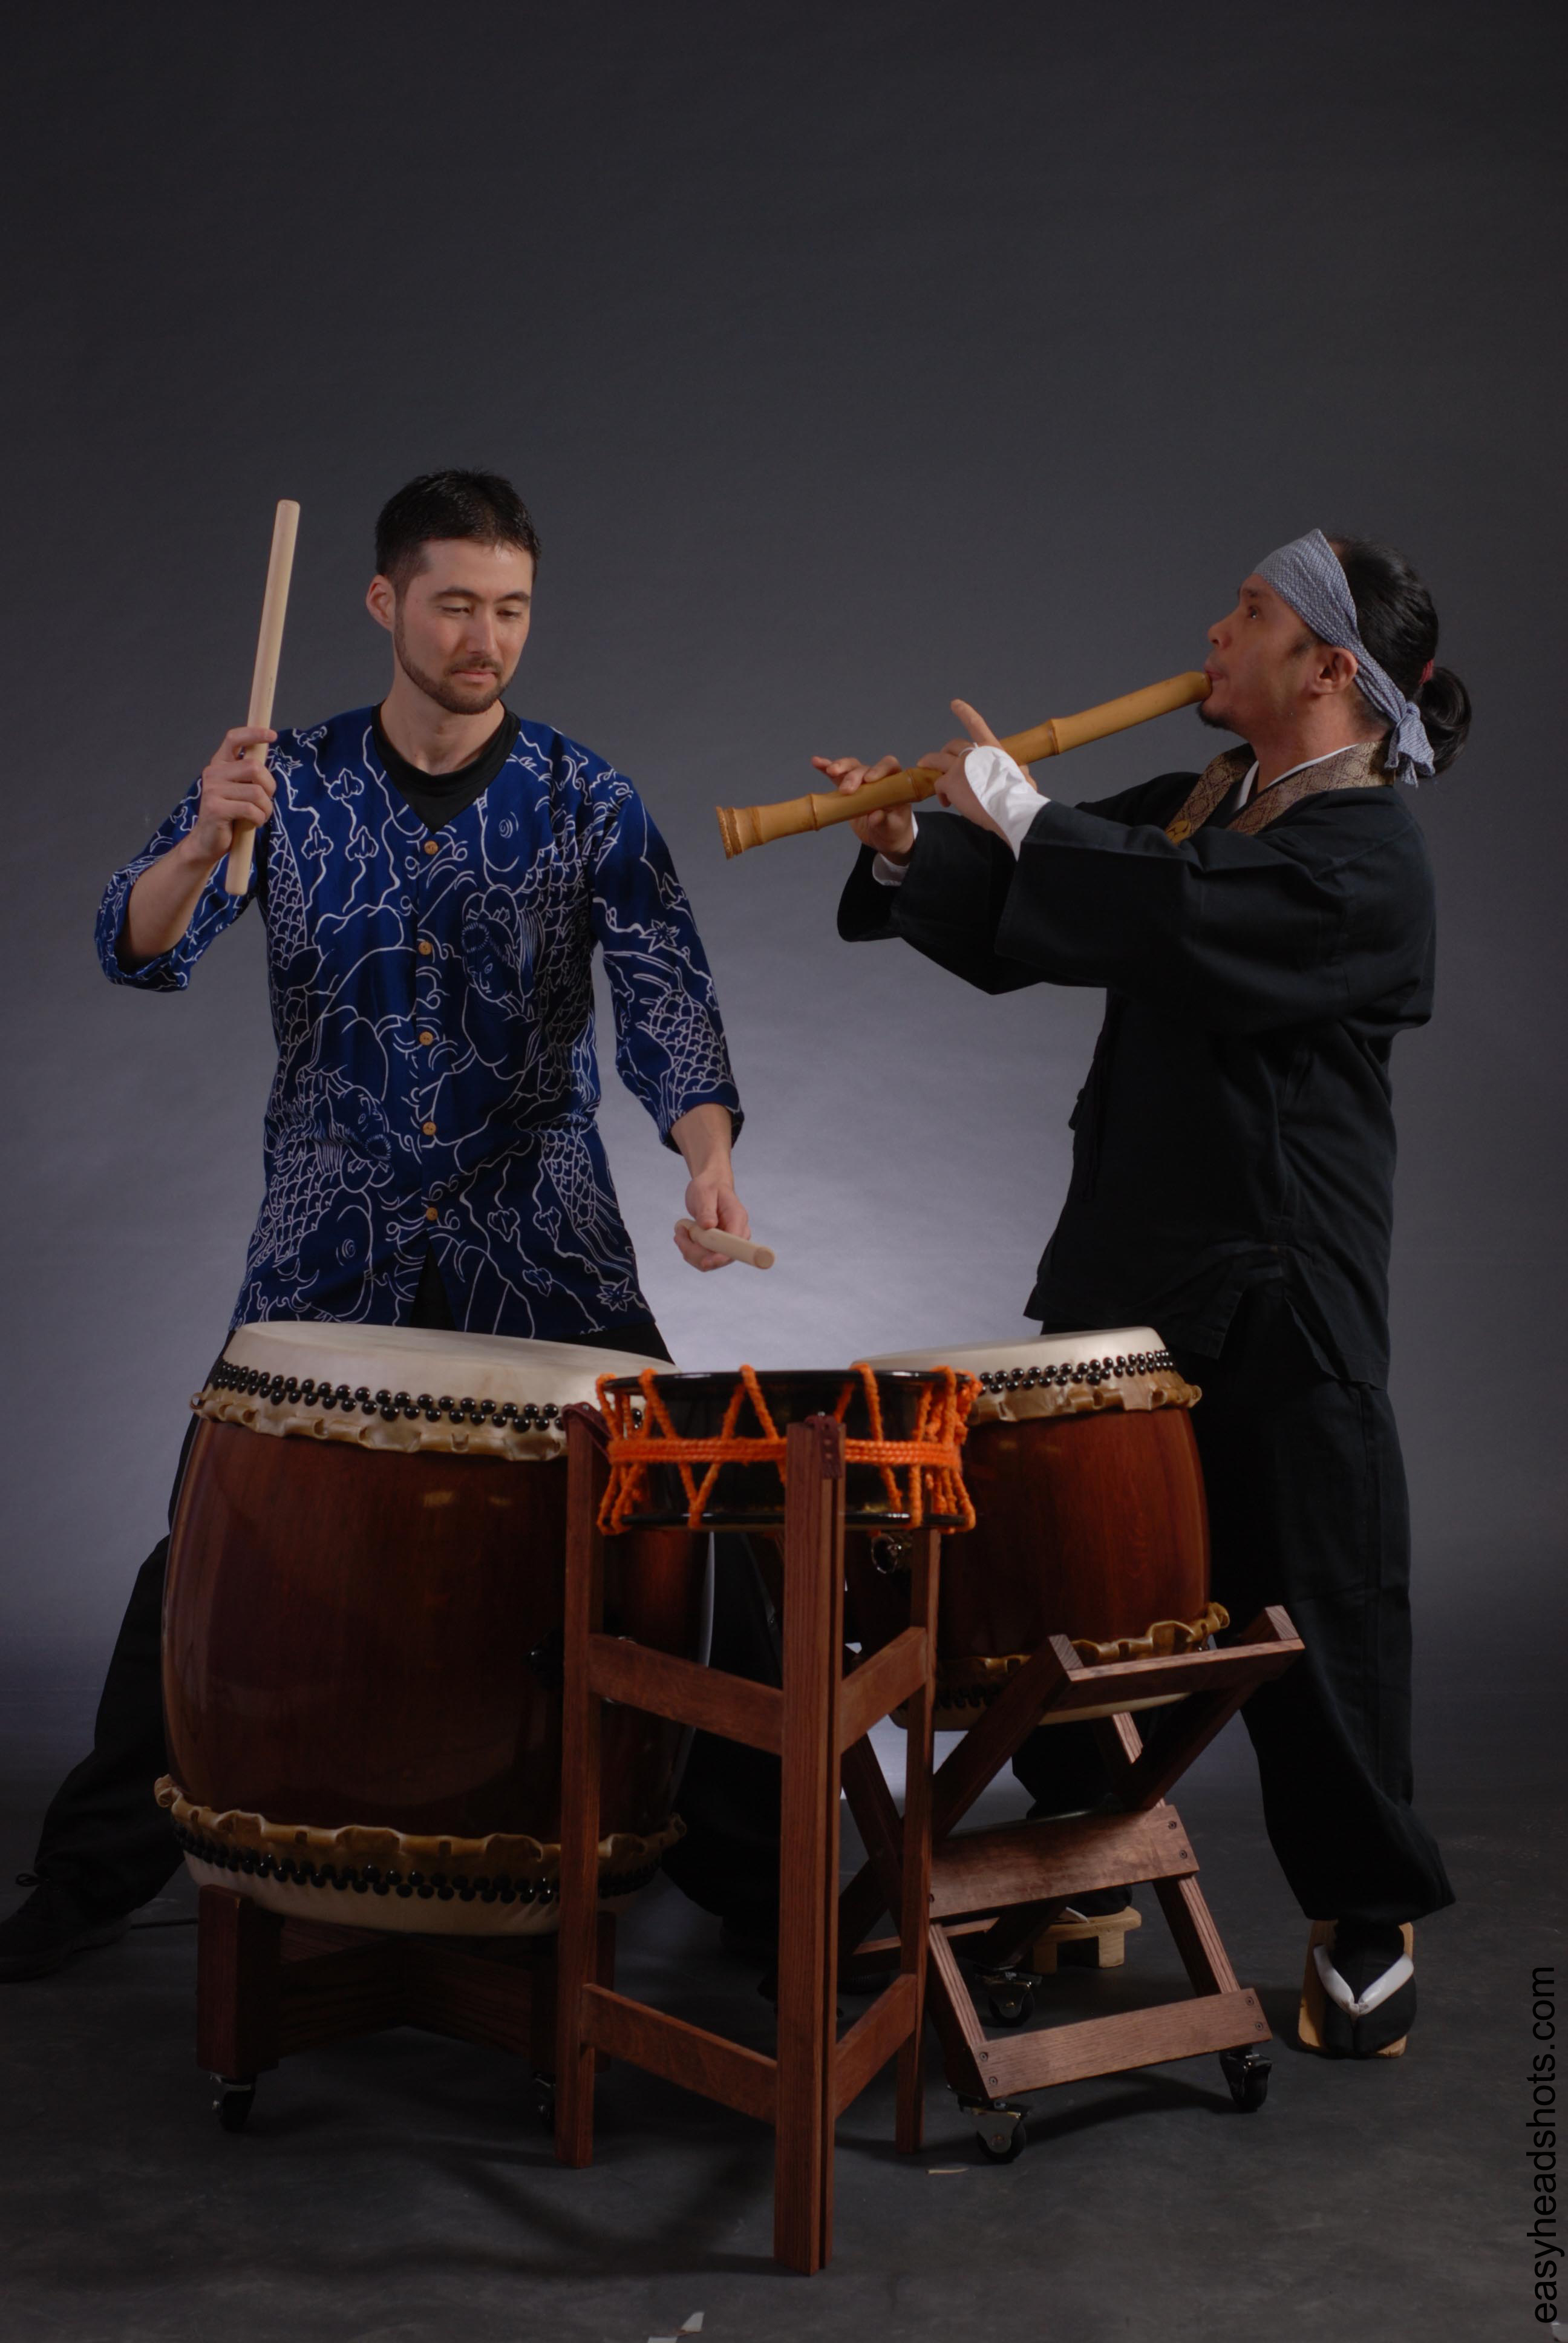
“A fascinating fusing of ancient Japanese and Eastern instruments and musical traditions with unique, modern configurations”
Maru is blazing new trails in the Japanese style of music through the innovative blending of shakuhachi bamboo flute and taiko drums with rhythms and sounds influenced from jazz, rock, middle east, ambient and collaborations around the world into original melodies and improvisation. The music resonating from the ensemble's stage is created through such instruments as vibraphones, Shakuhachi bamboo flute, koto (Japanese zither), Australian didgeridoo, Armenian duduk in tandem with the dynamic and subtly powerful sound of hybrid taiko-percussion. MARU explores the Japanese concept of "ma," or interval, as artists living in the Western world dominated by groove or beat-oriented music. In western music, the emphasis is creating movement through ascending and descending harmonies, melodies, rhythms – while in Japanese music as much energy goes into the ma or silence as into the sounds. The space in rhythm creates the feeling of movement and vitality in the music. "The bridge between this world and the other world (spirit), cultures, and realities is the empty space where there is room for music to enter," shakuhachi player Ryuzen says in his artist statement. Founder and artistic director of Bamboo-In Shakuhachi Retreat Centre based on the Sunshine Coast of British Columbia, Ryuzen was recently granted an honorary title of Daishihan (grandmaster) of Shakuhachi from one of Japan’s leading teachers, Yoshinobu Taniguchi for his skill in playing and work in spreading Shakuhachi throughout the world. He is the first Canadian and one of only a few non-Japanese to be awarded this esteemed honor.
Maru is a truly unique collaboration of 2 musicians that has a strong foundation in the traditional musical arts of Japan as well as western music. Since then, they have gone on to perform together at numerous musical festivals and events.
Alcvin Ryuzen Ramos is one of the leading teachers and performers of the shakuhachi in the world today. Born in Japan, Ryuzen spent many years studying shakuhachi flute in Japan and was eventually himself granted an honorary dai shihan (grand master) of shakuahchi. He is also a player of a variety of instruments (didgeridoo, hichiriki, biwa, duduk, guitar, guqin) and has been experimenting with new ways of playing traditional instruments as well as with synthesized and electronic music. He has taught and performed all over North America, Europe and Japan, and pursues an active solo as well as collaborative career, playing with such distinguished artists as Bill Laswell, Hun Huur Tuu Mongolian Throat Singers, Toshinori Kondo, Joseph Pepe Danza, Uzume Taiko, The Vancouver Symphonietta, Dharmakasa, Densabi, Isshin Denshin, Haagen & Ryuzen, as well as with dancer Colleen Lanki, and bagpipe fusion band Mearingstone. He has also performed at the World Shakuhachi Festivals in New York and Sydney Australia, Vancouver Jazz Festival, Vancouver New Music Festival, the World Sacred Music Festival in Japan, the Vancouver Sacred Music Festival, and opened for Anoushka Shankar and the Yoshida Brothers. He is the founder and director of the Bamboo-In Shakuhachi Retreat Centre on the Sunshine Coast of British Columbia.
Eien Hunter-Ishikawa is a versatile drummer, percussionist, and taiko player with a multifaceted musical background. Born in Japan, his passion for drumming started at an early age through the involvement of a youth taiko ensemble directed by Yutaka Ishizuka, a founding member of the greatly influential taiko ensemble Sukeroku Daiko. He earned his Bachelor of Music Education at Central Michigan University, where he performed, recorded, and toured as a member of the Robert Hohner Percussion Ensemble under the direction of the late Robert Hohner, and his Master of Music at the University of Hawaii at Manoa. During his time in Honolulu, Eien performed and toured extensively as a member of the Kenny Endo Taiko Ensemble throughout the United States and Europe and taught classes at the Taiko Center of the Pacific, a school of traditional and contemporary taiko. Currently based in Vancouver, British Columbia, he has toured internationally with Uzume Taiko and has performed with electro- acoustic groups Isshin Denshin Atmospheric Ensemble and Haagen & Ryuzen as well as dancer Colleen Lanki, bagpipe fusion band Mearingstone, Vancouver’s Silk Road Music, Japanese improvisation duo Maru, and the African band Kow Kanda. Eien is also an active instructor and composer involved in a wide range of projects spanning multiple genres and creative disciplines.
Maru’s Music is a fusion of Japanese folk melodies, jazz, rock, ambient, improvised. Instrumentation includes shakuhachi and shinobue (Japanese bamboo flutes), drum set, taiko, vibraphone, didgeridoo, bass, percussion, double reeds (hichiriki, duduk, piri), biwa (Japanese lute), koto (Japanese zither), and vocals. Please see the web links below for examples of our music.

Maru links on the web:

http://www.myspace.com/marusoundz

http://www.youtube.com/watch?v=mA88lHAEkuQ&feature=related

Contact:

Alcvin Ramos
Tel: 1.604.883.2023
Email: ryu.zen18@gmail.com

